DEVELOPMENT OF A WEB-BASED INTRUSION DETECTION AND ALERT SYSTEM

BY

CATHERINE EMMANUEL
SW/HND/F24/0085

SUBMITTED TO THE DEPARTMENT OF SOFTWARE AND WEB DEVELOPMENT, SCHOOL OF COMPUTING, THE FEDERAL POLYTECHNIC OFFA KWARA STATE. P.M.B 420, KWARA STATE.

IN PARTIAL FULFILLMENT OF THE REQUIREMENTS FOR THE AWARD HIGHER NATIONAL DIPLOMA (HND).

SUPERVISED BY:
MRS. MOHAMMED M. O.

JUNE, 2026

DECLARATION
I Catherine Emmanuel with matric number SW/HND/F24/0085 from the Department of Software and Web Development, School of Computing, Federal Polytechnic, Offa, Kwara State, hereby declares that the project titled DEVELOPMENT OF A WEB-BASED INTRUSION DETECTION AND ALERT SYSTEM consists of entirely my own work produced from research under supervision and that no part of it has been published or presented for another program elsewhere except for permissible references from other sources, which have been duly acknowledged.

CATHERINE EMMANUEL Date
SW/HND/F24/0085

CERTIFICATION
This is to certify that the research and write-up of this project carried out by Catherine Emmanuel with matric number SW/HND/F24/0085. The project has been scrutinized, certified and approved to have met the standard requirement for the award of Higher National Diploma (HND) in Software and Web Development.

_______________________________ _____________________
MRS. MOHAMMED M. O. DATE
SUPERVISOR

_______________________________ ______________________
MRS. MOHAMMED M. O. DATE
HEAD OF DEPARTMENT

DEDICATION
This project research work is dedicated to Almighty God that made the project successful, His name is exhorted above all.

ACKNOWLEDGEMENT
First and foremost, I acknowledged God Almighty for his protection and mercy over my life throughout the program on campus for making me to be among graduate as an HND holder, may his be the honor. I will not but acknowledge my lovely parent, MR/MRS. EMMANUEL for their parental support for financial and encouragement, I say thank you sir/ma. More so, I acknowledged my supervisor, Mrs. Mohammed M. O. for her guidance and support for the successful for this project may your life never experience set back and all your heart desire shall grant unto you. Finally, I acknowledged my able H.O.D, Mrs. Mohammed M. O. for his fatherly advice throughout my program on campus, I say thank you a lot sir.

ABSTRACT
Web applications have become a central part of modern communication, business operations, and data exchange. However, their increasing adoption has also made them a major target for cyberattacks such as SQL injection, cross-site scripting (XSS), and brute-force login attempts. These attacks exploit weaknesses in web applications and often go undetected until significant damage has been done. In many small and medium-scale systems, there is limited or no real-time mechanism for monitoring, detecting, and responding to such malicious activities. This project presents the design and implementation of a Web-Based Intrusion Detection and Alert System aimed at improving the security monitoring capabilities of web applications. The system is developed to continuously monitor incoming HTTP requests, analyze user activities, and detect potentially harmful patterns using a rule-based detection approach. When suspicious behavior is identified, the system generates real-time alerts and logs the incident for administrative review. The system architecture is built using Laravel as the backend framework, React for the frontend interface, and MySQL for data storage. A custom intrusion detection engine was implemented to evaluate user requests against predefined security rules. These rules are designed to detect common web attack patterns such as malicious input strings, repeated failed login attempts, and abnormal request behavior. The results of detected activities are displayed on an administrative dashboard, which provides real-time visibility into system security status. The proposed solution not only focuses on detection but also emphasizes response and monitoring. Alerts can be generated instantly and presented through the dashboard interface, enabling system administrators to take immediate action. In addition, all security events are stored in a structured log format for future analysis and auditing purposes. The outcome of this project demonstrates that a lightweight, rule-based intrusion detection system can significantly enhance the security posture of web applications without requiring complex or resource-intensive machine learning models. It is particularly suitable for small to medium-scale organizations that require an affordable and efficient security monitoring solution.
Keywords: Intrusion Detection System (IDS), Web Application Security, SQL Injection Detection, Cross-Site Scripting (XSS), Rule-Based Detection Engine, Real-Time Alert System, Security Monitoring Dashboard
CHAPTER ONE
INTRODUCTION
1.1 Background of the Study
The rapid evolution of web-based applications has significantly transformed the way services are delivered and accessed across various sectors such as education, finance, healthcare, and commerce. Web applications now support critical operations including data processing, authentication, communication, and online transactions. However, as these systems continue to expand in functionality and accessibility, they also become increasingly exposed to cyber threats. Modern web applications are frequently targeted by malicious actors who exploit vulnerabilities within system logic, input fields, and authentication mechanisms. Common attacks include SQL injection, cross-site scripting (XSS), brute-force login attempts, session hijacking, and unauthorized access attempts. These attacks are typically executed by manipulating user inputs or exploiting poorly secured backend systems, often resulting in data breaches or complete system compromise.
According to Kim et al. (2022), web-based systems remain highly vulnerable due to their exposure to public networks and continuous interaction with untrusted user inputs. SQL injection and XSS attacks remain particularly prevalent because many web applications fail to properly validate or sanitize user inputs before processing them. In addition, Patel and Singh (2023) emphasize that SQL injection and XSS attacks continue to dominate web security incidents due to weak input validation mechanisms and poor application design practices. These vulnerabilities allow attackers to manipulate database queries or inject malicious scripts into web pages, leading to unauthorized access or data theft. To address these challenges, various security mechanisms such as firewalls and Web Application Firewalls (WAFs) have been developed. However, traditional security systems are often insufficient in detecting real-time or evolving attack patterns. Research by Zhang et al. (2023) highlights that modern intrusion detection approaches must be adaptive and capable of responding to threats in real time.
Intrusion Detection Systems (IDS) have therefore become an essential component in modern cybersecurity frameworks. IDS are designed to monitor system or network activities and identify suspicious behavior based on predefined rules or learned patterns. However, many existing IDS solutions are either too complex, resource-intensive, or designed for large-scale enterprise environments. Recent research by Wang et al. (2023) shows that feature-based and optimized intrusion detection systems can improve detection efficiency while reducing computational overhead. Despite these advancements, there is still a gap between complex IDS models and practical implementations suitable for small and medium-scale web applications. Therefore, this project focuses on the development of a lightweight, efficient, and real-time web-based intrusion detection and alert system capable of monitoring HTTP requests, detecting malicious activities, and generating instant alerts.
1.2 Problem Statement
Despite continuous improvements in cybersecurity technologies, many web applications still lack effective real-time intrusion detection mechanisms. This exposes them to frequent cyberattacks such as SQL injection, XSS, and brute-force login attempts. Most existing intrusion detection systems are designed for enterprise-level infrastructures and are therefore too complex, expensive, or resource-intensive for small and medium-scale web applications. According to Ahmed et al. (2022), many traditional IDS implementations require high computational resources, making them unsuitable for lightweight web environments.
In addition, many web applications lack real-time monitoring and alerting systems, meaning that administrators often become aware of attacks only after damage has occurred. Wang et al. (2023) highlight that although many IDS solutions achieve high detection accuracy, they often fail to provide efficient real-time alert mechanisms. Furthermore, there is limited visibility into user behavior within many web applications, making it difficult to detect abnormal patterns such as repeated failed login attempts or suspicious request payloads. This creates a security gap that attackers can easily exploit. Therefore, this project aims to develop a lightweight web-based intrusion detection and alert system capable of real-time monitoring, detection, and response to malicious activities.
1.3 Aim of the Project
The aim of this project is to design and implement a web-based intrusion detection and alert system capable of monitoring web application activities in real time, detecting malicious behavior, and generating instant security alerts for administrators.
1.4 Objectives of the Project
The objectives of this project include:
- To detect malicious login attempts such as brute-force attacks
- To identify SQL injection and cross-site scripting (XSS) attacks
- To monitor and analyze user behavior patterns within a web application
- To design and implement a rule-based intrusion detection engine
- To generate real-time security alerts when suspicious activities are detected
- To develop an administrative dashboard for monitoring and managing security events
1.5 Scope of the Project
This project focuses on the design and implementation of a web-based intrusion detection and alert system. The scope includes:
- Monitoring HTTP requests within a web application environment
- Detecting SQL injection and XSS attack patterns
- Detecting brute-force login attempts
- Implementing a rule-based intrusion detection engine
- Generating real-time alerts and logging system activities
- Providing an administrative dashboard for security monitoring
The system is developed using Laravel (backend), React (frontend), and MySQL (database). However, it does not include full network-level intrusion detection, deep packet inspection, or advanced AI-based predictive models.
1.6 Significance of the Project
This project is significant because it provides a practical and lightweight solution to web application security challenges. Unlike complex intrusion detection systems that require high computational resources, this project is designed for real-time monitoring and efficient deployment in small and medium-scale environments. Kim et al. (2022) emphasize that real-time intrusion detection systems significantly improve response time to cyber threats, thereby reducing potential damage. In addition, Patel and Singh (2023) highlight the importance of lightweight intrusion detection systems in environments with limited computational resources.
This project also contributes to improving administrative awareness by providing real-time alerts and centralized monitoring dashboards, enabling faster response to security threats. Furthermore, this project serves as a useful academic and practical reference for students in computer science and software engineering, demonstrating how intrusion detection concepts can be applied in real web development environments.
1.7 Limitations of the Project
This project has the following limitations:
- It is based on a rule-based detection approach and may not detect unknown or zero-day attacks
- It does not include advanced machine learning or deep learning models
- It is limited to web application-level monitoring only
- Detection accuracy depends on the quality of predefined rules
- System performance may reduce under high traffic conditions due to real-time processing
1.9 Definition of Terms
1.9.1 Web Application
A web application is a software program that operates on a web server and is accessed through a web browser over a network such as the Internet or an intranet. Unlike traditional desktop applications, web applications do not require installation on individual user devices. Examples include online banking systems, e-commerce websites, student portals, and content management systems. In this project, the intrusion detection system is designed specifically to monitor and protect web application activities from malicious attacks.
1.9.2 Intrusion Detection System (IDS)
An Intrusion Detection System (IDS) is a cybersecurity tool designed to monitor, analyze, and detect unauthorized or suspicious activities within a computer system or network. The primary purpose of an IDS is to identify potential security threats and notify administrators before significant damage occurs. In this project, the IDS is implemented as a web-based solution that monitors incoming requests, analyzes user behavior, and generates alerts when malicious activities are detected.
1.9.3 SQL Injection (SQLi)
SQL Injection is a cyberattack technique in which an attacker inserts malicious SQL commands into input fields of a web application in an attempt to manipulate database queries. Successful SQL injection attacks can allow unauthorized access to sensitive information, modification of records, deletion of data, or complete compromise of the database. Detecting and preventing SQL injection attacks is one of the major objectives of this project.
1.9.4 Cross-Site Scripting (XSS)
Cross-Site Scripting (XSS) is a web application vulnerability that allows attackers to inject malicious scripts into web pages viewed by other users. These scripts may be used to steal session information, redirect users to malicious websites, or perform actions on behalf of victims without their consent. XSS attacks are among the most common web security threats and are therefore considered in the design of the proposed intrusion detection system.
1.9.5 Brute Force Attack
A brute force attack is a method used by attackers to gain unauthorized access to a system by repeatedly attempting different username and password combinations until the correct credentials are discovered. Such attacks often target login systems and can lead to account compromise if not properly detected or prevented. This project includes mechanisms for monitoring and identifying repeated failed login attempts associated with brute force activities.
1.9.6 Rule-Based Detection
Rule-based detection is an intrusion detection approach that relies on predefined security rules, signatures, or patterns to identify suspicious activities. When a user's action matches one of the predefined malicious patterns, the system flags the activity as a potential threat. In this project, rule-based detection is used to identify known attack patterns such as SQL injection attempts, XSS payloads, and abnormal login behaviors.
1.9.7 Real-Time Alert System
A real-time alert system is a mechanism that immediately notifies administrators or security personnel whenever suspicious or malicious activity is detected. The purpose of real-time alerts is to enable quick response and mitigation before an attack causes significant damage. In this project, alerts are generated instantly and displayed on the administrative dashboard whenever the intrusion detection engine identifies a potential security threat.
1.9.8 HTTP Request
An HTTP request is a communication message sent from a client, such as a web browser, to a web server requesting a resource or transmitting information. HTTP requests contain important details such as URLs, parameters, headers, and user inputs. Since many web attacks are delivered through manipulated HTTP requests, this project monitors and analyzes incoming requests to identify potentially malicious activities.
1.9.9 Authentication
Authentication is the process of verifying the identity of a user, device, or system before access is granted to protected resources. Common authentication methods include usernames and passwords, biometric verification, one-time passwords (OTP), and multi-factor authentication. In this project, authentication-related activities such as login attempts are monitored to detect suspicious behavior and possible brute force attacks.
CHAPTER TWO
LITERATURE REVIEW
2.1.1 Concept of Intrusion Detection Systems
The rapid advancement of information and communication technologies has led to an unprecedented increase in the deployment of computer networks and web-based applications across various sectors of society. Governments, educational institutions, healthcare organizations, financial institutions, and private businesses now depend heavily on interconnected information systems to store, process, and transmit critical information. While these technological advancements have improved operational efficiency and accessibility, they have also introduced numerous security challenges that threaten the confidentiality, integrity, and availability of digital resources. As cyber threats continue to evolve in sophistication and frequency, organizations are increasingly seeking effective mechanisms to detect and respond to malicious activities before significant damage occurs.
One of the most important technologies developed to address these security concerns is the Intrusion Detection System (IDS). An Intrusion Detection System is a cybersecurity solution designed to monitor, analyze, and evaluate activities occurring within a computer system, network, or application environment for signs of malicious behavior, policy violations, unauthorized access attempts, or other security-related incidents. The primary purpose of an IDS is not necessarily to prevent attacks but to identify and report suspicious activities so that appropriate response actions can be taken in a timely manner (Scarfone & Mell, 2007).
Historically, the concept of intrusion detection emerged as a response to the limitations of traditional security mechanisms such as firewalls and access control systems. Although firewalls serve as an important first line of defense by filtering incoming and outgoing traffic, they cannot detect all forms of attacks, especially those that originate from legitimate users or exploit vulnerabilities within authorized applications. Consequently, organizations require additional monitoring mechanisms capable of identifying threats that bypass preventive controls. Intrusion Detection Systems were developed to fill this security gap by continuously observing system behavior and detecting activities that deviate from established security policies.
The theoretical foundation of intrusion detection can be traced to the work of Anderson (1980), who proposed the concept of monitoring audit trails to identify unauthorized activities within computer systems. Building upon this foundation, Denning (1987) introduced a formal intrusion detection model that established many of the principles still used in modern IDS technologies. Denning's model emphasized the importance of collecting audit data, analyzing user behavior, establishing normal activity profiles, and identifying anomalies that may indicate security violations. This model remains one of the most influential contributions to intrusion detection research and has served as the basis for numerous IDS architectures developed over the years.
An Intrusion Detection System typically operates by collecting data from one or more sources, analyzing the collected information using predefined rules or behavioral models, and generating alerts whenever suspicious activities are detected. The monitoring process may involve examining network packets, system logs, application requests, user authentication records, database queries, file modifications, or other forms of digital activity. The effectiveness of an IDS depends largely on its ability to accurately distinguish between legitimate activities and malicious actions while minimizing false alarms.
The operation of a typical IDS consists of four major phases. The first phase is data collection, during which information is gathered from various monitoring points within the system. The second phase involves preprocessing and normalization, where collected data is transformed into a format suitable for analysis. The third phase is the detection phase, where the system applies predefined rules, signatures, statistical models, or machine learning algorithms to identify suspicious behavior. The final phase is the response and alerting phase, during which security notifications are generated and forwarded to administrators for investigation and remediation.
Modern intrusion detection systems play a critical role in organizational cybersecurity strategies because they provide visibility into ongoing activities that may otherwise go unnoticed. By identifying threats at an early stage, IDS technologies enable security personnel to investigate incidents promptly, minimize potential damages, and improve overall security posture. In addition, IDS logs and alert records provide valuable forensic evidence that can be used during incident response investigations and post-attack analyses.
Another important characteristic of intrusion detection systems is their ability to support compliance with security standards and regulatory requirements. Many international cybersecurity frameworks, including the National Institute of Standards and Technology (NIST) Cybersecurity Framework and ISO/IEC 27001 Information Security Management Systems, emphasize the importance of continuous monitoring and security event detection. Organizations implementing IDS technologies are therefore better positioned to meet regulatory obligations while improving their resilience against cyber threats.
In recent years, the increasing complexity of cyberattacks has led to significant advancements in intrusion detection technologies. Traditional rule-based systems have evolved into sophisticated solutions capable of leveraging artificial intelligence, machine learning, behavioral analytics, and threat intelligence feeds to improve detection accuracy. Nevertheless, many organizations, particularly small and medium-sized enterprises, continue to rely on rule-based and signature-based IDS solutions due to their simplicity, cost-effectiveness, and ease of deployment. Such systems remain highly effective for detecting common attacks such as SQL Injection, Cross-Site Scripting, brute-force authentication attempts, and unauthorized access activities.
The Web-Based Intrusion Detection and Alert System developed in this project adopts a rule-based intrusion detection approach. The system continuously monitors HTTP requests, authentication activities, and user interactions within the application environment. By comparing incoming requests against predefined attack signatures and detection rules, the system identifies potentially malicious activities and generates real-time security alerts. This approach provides an effective and lightweight security solution that is particularly suitable for web applications deployed in resource-constrained environments.
Furthermore, the integration of intrusion detection capabilities directly into a web application provides several advantages over traditional network-level monitoring solutions. Since the system operates at the application layer, it can analyze user inputs, request parameters, authentication attempts, and session activities with greater contextual awareness. This allows the system to detect application-specific attacks that may not be visible to conventional network-based intrusion detection systems.
As cyber threats continue to increase globally, the role of intrusion detection systems will remain essential in maintaining the security, reliability, and trustworthiness of information systems. Organizations that implement effective intrusion detection mechanisms are better equipped to identify threats, respond to incidents, and protect valuable digital assets from compromise. Consequently, IDS technologies have become a fundamental component of modern cybersecurity architectures and continue to play a vital role in safeguarding web applications and other information systems against emerging threats.
2.2 Review of Related Works
Recent developments in intrusion detection systems have been significantly influenced by the increasing sophistication of cyberattacks targeting web applications and network infrastructures. Researchers have continuously explored different approaches to improve the detection of malicious activities, particularly focusing on SQL injection, cross-site scripting, brute force attacks, and other forms of application-layer exploits. These studies have shifted from traditional signature-based systems toward more intelligent models such as machine learning, deep learning, and hybrid detection frameworks. However, despite these advancements, many of the proposed systems still face challenges related to computational complexity, real-time detection capability, and adaptability to lightweight web environments.
A study conducted on deep learning-based web application firewalls demonstrated the effectiveness of neural network models in identifying complex attack patterns within HTTP requests. The research showed that deep learning techniques significantly improve detection accuracy by learning hidden patterns in data that are often missed by traditional rule-based systems. However, the study also highlighted a major limitation, which is the high computational cost and dependency on large datasets for training. This makes such systems less suitable for deployment in small-scale or resource-constrained environments, where real-time performance and simplicity are critical requirements.
In another related work focusing on SQL injection and cross-site scripting detection, researchers implemented a signature-based intrusion detection model that relied on predefined patterns and rule matching techniques. The system was designed to analyze user inputs and compare them against a database of known malicious signatures. The results showed that this approach is highly effective in detecting common attack patterns such as tautological SQL queries and script injection attempts. However, the study also revealed that signature-based systems struggle to detect obfuscated or zero-day attacks that do not match existing patterns. This limitation indicates that while rule-based systems are efficient and lightweight, they require continuous updates to remain effective against evolving threats.
Further research introduced a staged SQL injection detection model that classified attacks into different phases, such as reconnaissance, injection, exploitation, and data extraction. This approach provided deeper insight into attacker behavior and improved forensic analysis after detection. The model demonstrated improved visibility into attack progression, allowing administrators to understand not only that an attack occurred but also how it evolved over time. Despite its advantages, the system was complex to implement and required structured datasets and significant computational resources, which limits its applicability in lightweight web systems.
Another significant contribution in the field of intrusion detection is the development of real-time deep neural network-based IDS systems. These systems analyze network traffic continuously and classify it into normal or malicious categories using trained neural models. The results of these studies indicate that deep learning-based IDS solutions can achieve very high detection accuracy across multiple types of attacks. However, the requirement for continuous training, high processing power, and large datasets presents a major challenge for real-time deployment in web applications, especially in environments where computational resources are limited.
Research focusing on alert management systems has also become increasingly relevant in modern intrusion detection studies. Some researchers proposed real-time alert prioritization systems designed to reduce alert fatigue in security monitoring environments. These systems assign severity levels to detected threats based on predefined criteria such as confidence score, attack type, and contextual behavior. The results showed that structured alert systems improve incident response efficiency by allowing administrators to focus on the most critical threats first. However, these systems are often designed for large enterprise environments and depend on complex security information and event management (SIEM) infrastructures, making them unsuitable for smaller applications.
Studies on network intrusion detection using dimensionality reduction techniques have also contributed to improving system efficiency. These approaches aim to reduce the number of features analyzed during intrusion detection, thereby improving processing speed and reducing computational overhead. While these methods enhance performance, they sometimes result in the loss of important information, which can negatively impact detection accuracy. This trade-off between efficiency and accuracy remains a key challenge in intrusion detection research.
Cross-site scripting detection has also been widely studied in recent years. Researchers have developed systems that analyze script patterns, DOM-based behavior, and event-driven attacks to detect malicious code injection into web applications. These studies confirm that XSS remains one of the most common web vulnerabilities due to insufficient input validation and improper output encoding. Although advanced detection techniques improve accuracy, they often require complex processing mechanisms that may not be practical for lightweight web applications.
Pattern recognition-based intrusion detection systems have also been widely adopted due to their simplicity and efficiency. These systems rely on predefined rules and patterns to classify incoming requests as either normal or malicious. Research findings consistently show that pattern-based systems are highly effective in detecting known attack signatures while maintaining low computational overhead. However, they lack adaptability and are unable to detect previously unseen attack variations, which limits their effectiveness in dynamic threat environments.
Incremental learning-based intrusion detection systems have been introduced to address the limitation of static models. These systems are capable of continuously updating their detection capabilities without requiring complete retraining. This allows them to adapt to new attack patterns over time. Despite their advantages, incremental learning systems are often complex to design and require continuous data input, making them difficult to implement in lightweight environments.
Hybrid intrusion detection systems combining machine learning techniques such as Random Forest and fuzzy logic have also been explored. These systems aim to improve detection accuracy and reduce false positives by combining multiple analytical approaches. Although they demonstrate strong performance in detecting complex attack patterns, they are computationally expensive and require significant processing resources, which limits their applicability in small-scale systems.
From the reviewed literature, it is evident that while advanced intrusion detection systems provide high accuracy and adaptability, they often come with increased complexity, higher computational cost, and dependency on large datasets. On the other hand, rule-based and signature-based systems remain widely used in practical applications due to their simplicity, efficiency, and ease of implementation. However, their inability to detect unknown attacks presents a significant limitation.
This gap in existing research highlights the need for a lightweight, real-time intrusion detection system that can effectively detect common web-based attacks such as SQL injection, cross-site scripting, and brute force attempts while maintaining simplicity and fast response time. Additionally, there is a lack of systems that integrate detection, alert generation, IP blocking, and administrative monitoring into a unified web-based platform.
The proposed project addresses these challenges by developing a web-based intrusion detection and alert system that combines rule-based detection, signature matching, brute force monitoring, and real-time alert generation. The system is designed to operate efficiently within a web application environment using a lightweight architecture, making it suitable for small and medium-scale deployments where advanced machine learning systems may not be feasible.

CHAPTER THREE: RESEARCH METHODOLOGY
3.1 Data Collection
Data collection is a fundamental stage in the development of this research work because it provides the necessary information required to understand the existing system, identify its limitations, and design an improved solution. In this study, both primary and secondary data collection methods were employed to ensure that the research is comprehensive, accurate, and well-grounded in real-world conditions.
Primary data refers to information that is collected directly from the original source for the specific purpose of this research. In this study, primary data was obtained through interviews, questionnaires, and direct observation. Interviews were conducted with IT personnel, system administrators, and individuals familiar with network security operations. These interviews provided detailed insights into common security challenges such as unauthorized access attempts, network intrusion patterns, and limitations of existing security mechanisms. The responses obtained revealed that many systems lack real-time monitoring capabilities and effective automated response mechanisms for detecting threats.
Questionnaires were also distributed to users of web-based systems to gather quantitative and qualitative data regarding their experiences with system security. These questionnaires focused on areas such as frequency of cyberattacks, awareness of security threats, and satisfaction with existing security systems. The responses collected helped in identifying patterns in user experience and security concerns across different system environments. The questionnaire design and detailed responses are documented in the appendix for reference.
Direct observation was another important method used in this study. This involved monitoring a controlled web environment to analyze how incoming traffic behaves under normal and abnormal conditions. Through observation, it was possible to identify suspicious activities such as repeated login attempts, unusual request patterns, and abnormal traffic spikes that may indicate potential intrusion attempts. This method was particularly useful in understanding how attacks manifest in real-time systems. Figure 3.2 shows the simulated environment used for observing network behavior. It illustrates how web traffic is continuously monitored to detect abnormal activities that may indicate intrusion attempts.
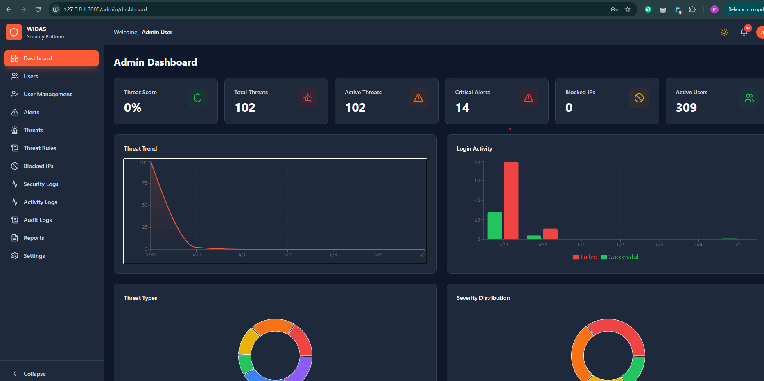Figure 3.1 System Observation and Network Traffic Monitoring Environment
Secondary data, on the other hand, was obtained from existing literature, textbooks, research journals, conference papers, and reputable online cybersecurity resources. These sources provided theoretical foundations and technical background on intrusion detection systems, network security principles, and cyber threat analysis. The use of secondary data ensured that the research is aligned with existing knowledge and best practices in the field of cybersecurity.
3.2 Description of the Proposed System
The proposed system is a Web-Based Intrusion Detection System designed to monitor, analyze, and detect malicious activities within web applications in real time. The system is developed to enhance the security of web-based platforms by identifying potential threats such as unauthorized access attempts, SQL injection attacks, cross-site scripting attacks, brute force login attempts, and abnormal network traffic behavior. The system is intended to provide continuous monitoring and immediate response capabilities to ensure the integrity, confidentiality, and availability of web resources. The system operates by continuously capturing incoming HTTP requests and analyzing them using a combination of rule-based detection techniques and behavioral analysis methods. Each request is evaluated against predefined security rules and patterns that represent known attack signatures. When a request deviates from normal behavior or matches a known malicious pattern, the system flags it as suspicious and triggers an alert mechanism. This alert is then stored in the system database and displayed on the administrator dashboard for further action.
The architecture of the proposed system is designed in a layered format to ensure modularity, scalability, and ease of maintenance. The system consists of a user interface layer, a detection engine layer, a database layer, and a notification module. The user interface layer provides an interactive dashboard through which administrators can monitor system activities, view alerts, and manage security configurations. The detection engine serves as the core component of the system and is responsible for analyzing incoming requests and identifying potential threats. The database layer stores all system data including logs, alerts, user information, and threat records, while the notification module handles real-time alert delivery to administrators. Figure 3.3 Architectural Design of the Proposed Intrusion Detection System presents a visual representation of the system architecture. It shows how data flows from the user interface through the detection engine into the database and alert system, illustrating the interaction between different system components.
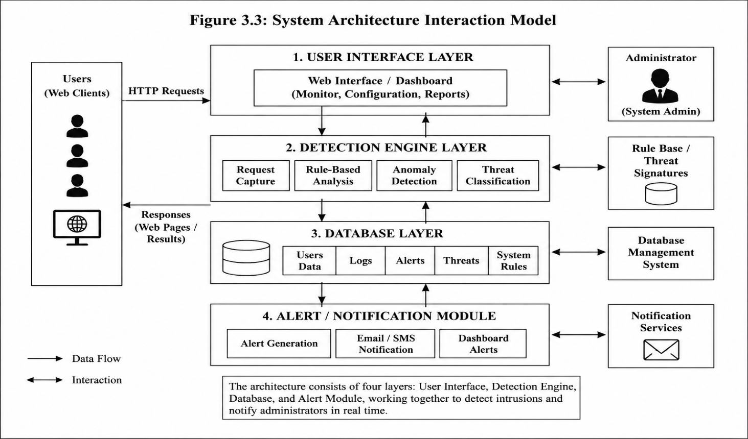
Figure 3.3 System Architecture Interaction Model
To further explain the internal structure and behavior of the system, modeling techniques such as Data Flow Diagrams (DFD), Entity Relationship Diagrams (ERD), and logical system models are employed. The Data Flow Diagram provides a graphical representation of how data moves within the system, starting from external entities such as users and ending at internal processes such as detection and storage. The Entity Relationship Diagram represents the structure of the database, showing entities such as users, logs, alerts, and threats, and defining the relationships between them. For instance, a single user can generate multiple logs, and each log may result in one or more alerts depending on the nature of the activity. Figure 3.4 represents the system as a single process interacting with external entities such as users and administrators. It shows the flow of input requests into the system and the output of alerts and reports.
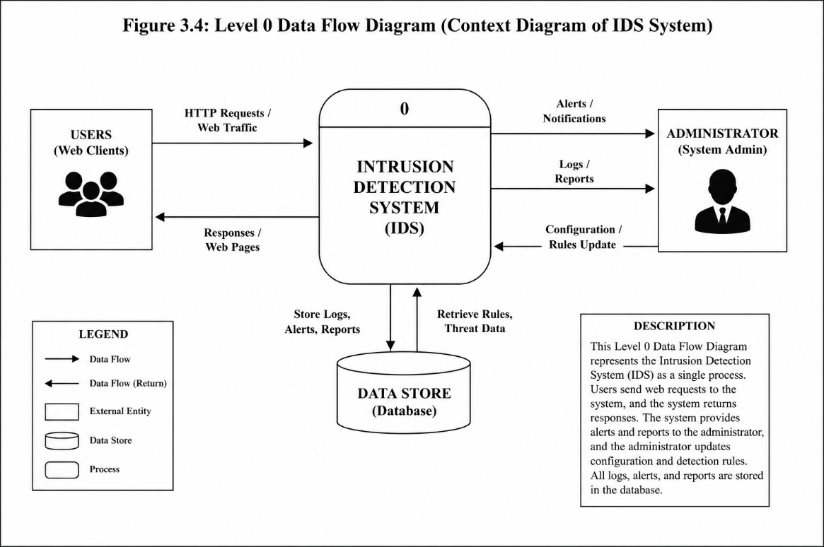
Figure 3.5 breaks down the system into sub-processes such as request monitoring, analysis, detection, logging, and alert generation, providing a more detailed view of system operations. Figure 3.6 titled “Entity Relationship Diagram of the Intrusion Detection System Database Structure” illustrates how system entities are related. It shows how logs are linked to users, how alerts are generated from logs, and how threats are categorized within the database structure.

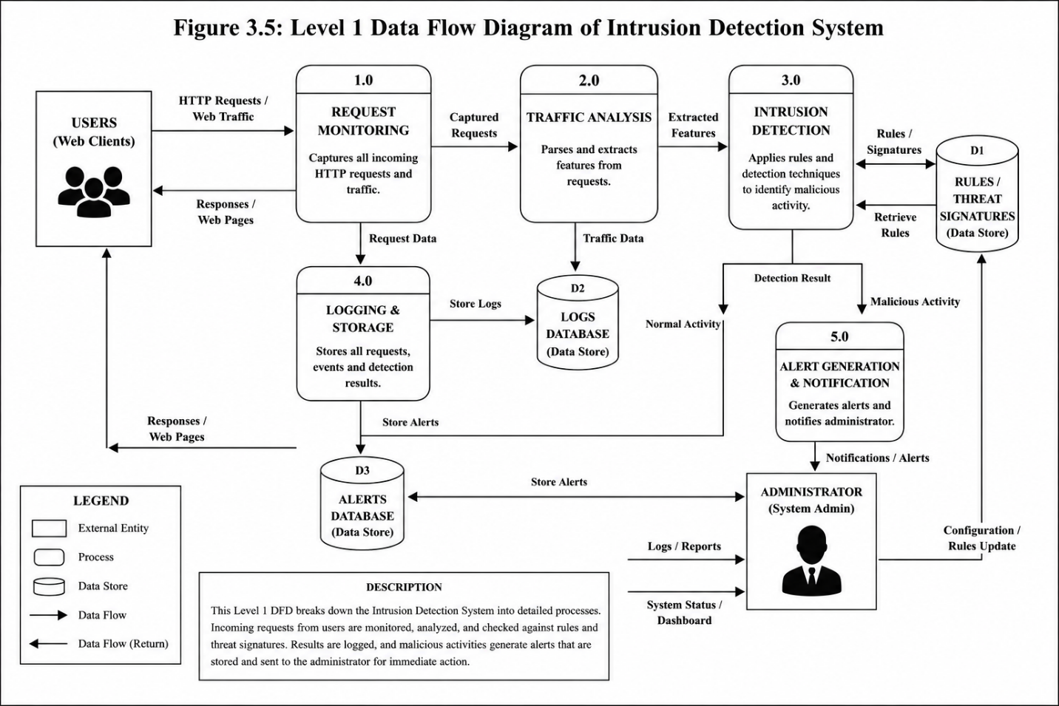
3.3 Analysis of the Proposed System
The analysis of the proposed system involves a detailed examination of how the system processes input data, generates output, and manages stored information within the database. This section is essential in understanding the internal functioning of the intrusion detection system and how it responds to different types of user activities and network behaviors.
The system receives input from multiple sources including HTTP requests, login attempts, API calls, and network traffic data. These inputs represent all interactions between users and the web application. Each request is captured in real time and passed into the detection engine for analysis. The input stage is critical because it determines the quality and accuracy of the detection process.
📌 Figure 3.7 titled “Input Flow into the Intrusion Detection System” shows how different types of input data are captured from users and external sources and transmitted into the system for processing. It highlights the continuous nature of data collection in a web-based environment.
Once input is received, the system enters the processing stage where the detection engine analyzes the data using predefined rules and anomaly detection techniques. During this stage, each request is parsed, inspected, and compared against known attack signatures and behavioral patterns. The system evaluates whether the request is legitimate or malicious based on its characteristics. If the request matches a known threat pattern or deviates significantly from normal behavior, it is classified as suspicious.
📌 Figure 3.8 titled “Intrusion Detection Processing Workflow” illustrates the step-by-step processing of incoming requests, showing how data is analyzed and classified within the detection engine.
The output stage of the system involves generating meaningful results based on the analysis performed during processing. These outputs include real-time alerts, system notifications, detailed logs of detected activities, and security reports that can be used for further investigation. The output is presented to the system administrator through a dashboard interface that allows for quick response to potential threats.
📌 Figure 3.9 titled “System Output and Alert Notification Interface” shows how alerts and security notifications are displayed to the administrator when suspicious activities are detected. It demonstrates the real-time nature of the system’s response mechanism.
The database plays a central role in storing and managing all system-related data. It is structured to ensure efficient storage, retrieval, and integrity of information. The database consists of multiple tables including users, logs, alerts, and threats. Each table is designed to store specific types of information, and relationships between tables ensure that data remains consistent and well-organized. For example, each log entry is associated with a specific user, and alerts are generated based on log analysis.
📌 Figure 3.10 titled “Database Schema of the Intrusion Detection System” illustrates the structure of the database and shows how different tables are related to each other to support system functionality.

3.4 System Design
The system design phase focuses on translating the system requirements into a structured technical framework that guides implementation. The design ensures that the system is efficient, scalable, maintainable, and capable of achieving its intended objectives.
The system is designed using an object-oriented and modular approach, where each component of the system is developed as an independent module responsible for a specific function. This design approach improves system flexibility and makes it easier to maintain and upgrade individual components without affecting the entire system. The modular structure also enhances scalability, allowing new features to be added in the future without major system restructuring.
Unified Modeling Language (UML) diagrams are used to represent the design of the system in a standardized format. The use case diagram illustrates the interaction between system users and the system itself, showing how administrators interact with features such as monitoring traffic, viewing alerts, and managing logs. The activity diagram represents the workflow of the system from the moment a request is received to the point where it is analyzed and classified. The sequence diagram describes the interaction between system components in chronological order, showing how data moves between the user interface, detection engine, and database. The class diagram defines the structure of the system in terms of classes such as User, Log, Alert, and DetectionEngine, including their attributes and methods.
📌 Figure 3.11 titled “Use Case Diagram of the Intrusion Detection System” illustrates the interaction between the system and its users, showing the various functionalities available to administrators.
📌 Figure 3.12 titled “Activity Diagram of Intrusion Detection Workflow” represents the step-by-step process of how the system handles incoming requests and generates alerts.
📌 Figure 3.13 titled “Sequence Diagram of System Component Interaction” shows the chronological interaction between different system components during intrusion detection.
📌 Figure 3.14 titled “Class Diagram of the Intrusion Detection System” illustrates the structure of system classes and their relationships.
Finally, the system undergoes feasibility analysis to determine its practicality. From a technical perspective, the system can be implemented using widely available technologies such as PHP, Python, JavaScript, and MySQL. Operationally, the system is designed to be user-friendly and requires minimal training for administrators. Economically, the use of open-source tools ensures that the system is cost-effective and suitable for academic implementation. In terms of schedule feasibility, the system can be completed within the timeframe allocated for final year project development.

CHAPTER FOUR: SYSTEM IMPLEMENTATION, RESULTS PRESENTATION, TESTING AND DOCUMENTATION
4.1 System Requirements
This section should comprehensively discuss the hardware and software resources required for the successful implementation and operation of the proposed Web-Based Intrusion Detection System. The requirements define the minimum resources necessary to ensure efficient system performance and reliability.
4.1.1 Hardware Requirements
The hardware requirements represent the physical components required to develop, deploy, and operate the system. The implementation of the proposed intrusion detection system requires a computer system with adequate processing power, memory capacity, storage resources, and network connectivity. A computer system equipped with at least an Intel Core i3 processor or equivalent is sufficient for development and testing purposes, although higher specifications may improve performance when handling large amounts of traffic data. A minimum Random-Access Memory (RAM) capacity of 4 GB is required to support the simultaneous execution of the web server, database server, and intrusion detection modules. In addition, a minimum storage capacity of 500 GB is recommended to accommodate source code files, system logs, security records, database contents, and backup data. Reliable network connectivity is also necessary because the system operates within a web environment where incoming requests must be continuously monitored and analyzed. Input devices such as a keyboard and mouse facilitate user interaction with the system, while a display monitor enables administrators to access dashboards, reports, and security alerts.
Table 4.1: Hardware Requirements for the Proposed System
Hardware Component | Specification
Processor | Intel Core i3 or Higher
RAM | 4 GB Minimum
Storage | 500 GB HDD/SSD
Monitor | Standard Display Monitor
Input Devices | Keyboard and Mouse
Network | Internet Connectivity
4.1.2 Software Requirements
The software requirements consist of the applications, frameworks, programming languages, and supporting tools used in the development and deployment of the proposed system. The intrusion detection system was developed using modern web technologies to ensure scalability, efficiency, and maintainability. The development environment includes Visual Studio Code as the integrated development environment, PHP as the server-side scripting language, MySQL as the database management system, and Apache Web Server provided through XAMPP. Additional technologies such as HTML, CSS, JavaScript, and Bootstrap were utilized to create an interactive and responsive user interface.
Table 4.2: Software Requirements for the Proposed System
Software | Purpose
Windows 10/11 | Operating System
XAMPP | Local Server Environment
PHP | Backend Development
MySQL | Database Management
HTML/CSS | User Interface Design
JavaScript | Client-side Interactivity
Bootstrap | Responsive Design
Visual Studio Code | Code Development
4.2 System Implementation
This section describes the practical implementation of the proposed system based on the analysis and design presented in the previous chapters. The implementation phase transforms the architectural design and system requirements into a fully functional application capable of detecting and reporting intrusion attempts. The system was implemented using a modular architecture where each component performs a specific function. The user interface module handles user interactions, the detection module performs traffic analysis and intrusion detection, the database module manages data storage, and the notification module generates security alerts.
4.2.1 Input Interface
The input interface serves as the entry point through which data is supplied to the system. In the proposed intrusion detection system, input data consists of user requests, login credentials, network traffic information, and administrator configurations. The interface was designed to ensure ease of use while maintaining data validation and security controls.
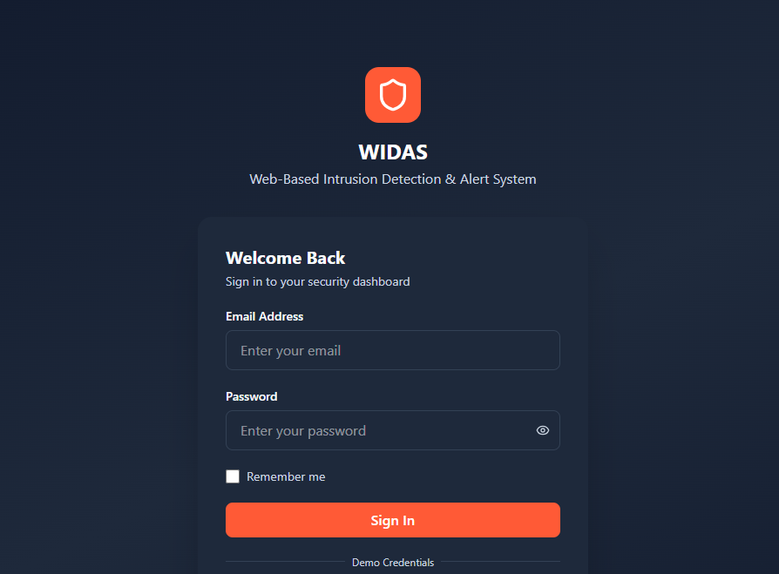
Figure 4.1: User Login Interface
Fig 4.1 interface enables users and administrators to authenticate themselves before accessing system resources.

4.2.2 Output Interface
The output interface presents processed information generated by the intrusion detection system. Outputs include security alerts, detected intrusion reports, activity logs, and dashboard analytics. The interface provides administrators with real-time information required for making security decisions and responding to incidents 4.3 Displays overall system status, intrusion statistics, alert summaries, and monitoring activities.
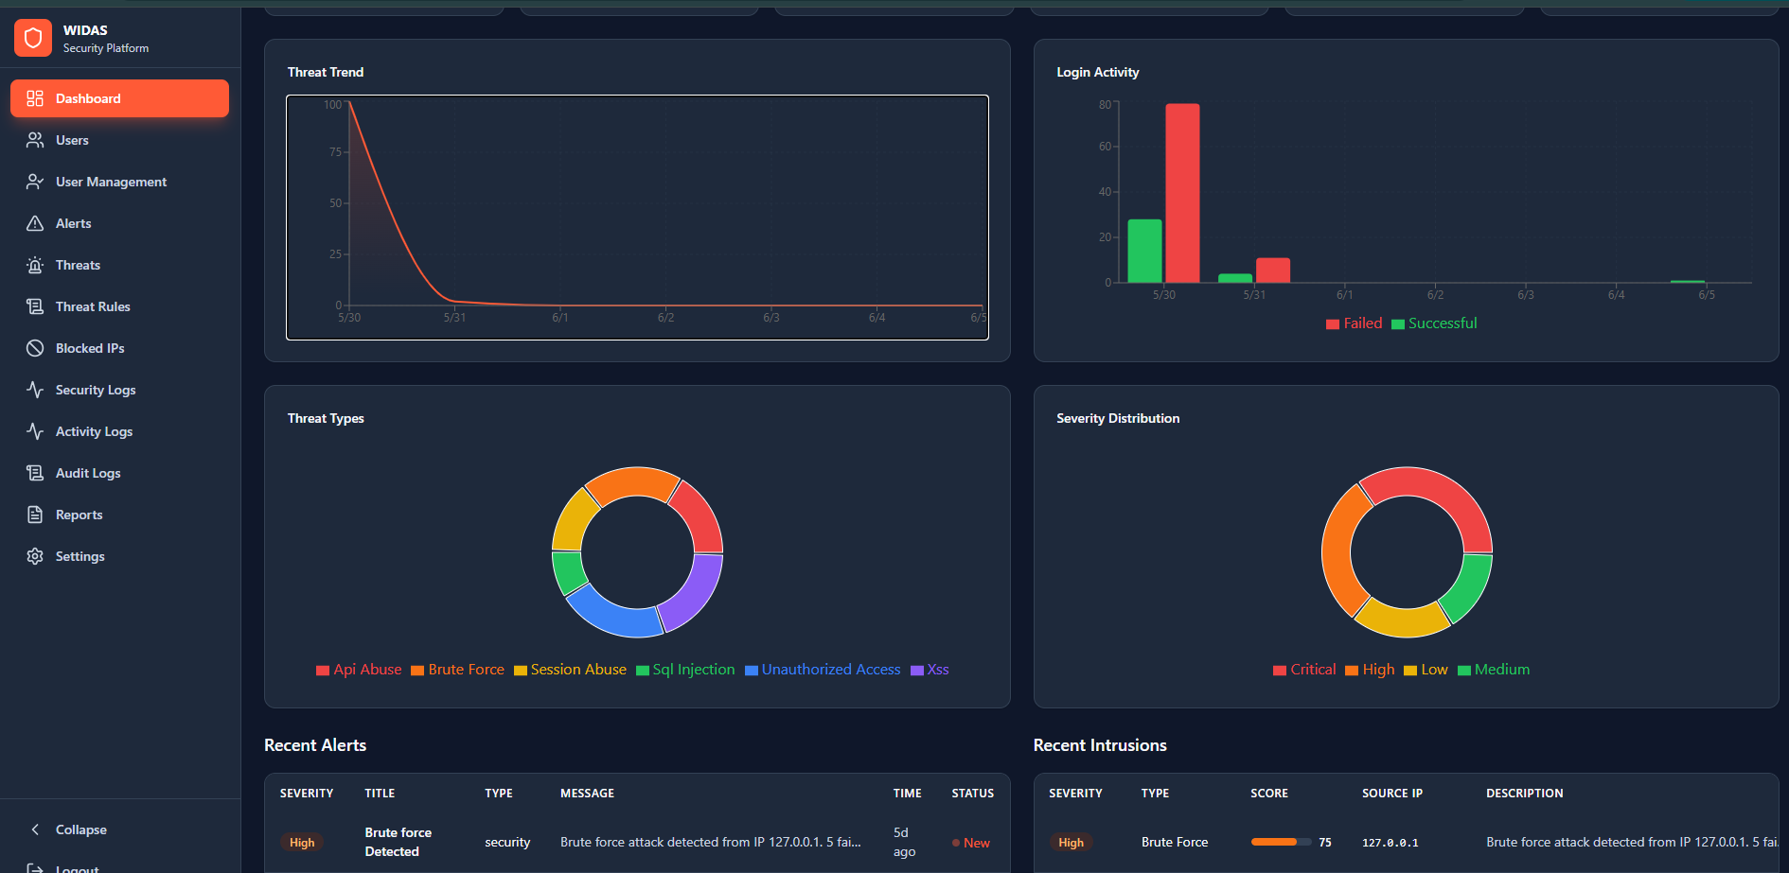
Figure 4.3: Administrator Dashboard
4.2.3 Database Interface
The database interface facilitates communication between the application and the database management system. It enables the storage, retrieval, modification, and deletion of system records while maintaining data integrity and consistency. Fig 4.5 Shows the database structure used for managing users, logs, alerts, and threat information.

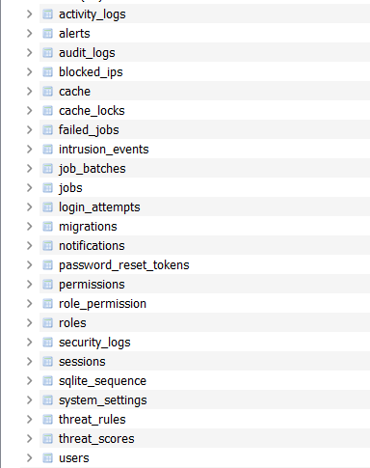
Figure 4.5: Database Management Interface
4.3 Results Presentation
This section presents the outcomes obtained after implementing the proposed intrusion detection system. The results demonstrate the effectiveness of the system in detecting suspicious activities and generating timely alerts.
Table 4.3: Intrusion Detection Results
Threat Type | Attempts Detected | Detection Rate (%)
SQL Injection | 10 | 5
XSS Attack | 3 | 10
Brute Force | 40 | 4
Unauthorized Access | 2 | 50
Chart Presentation

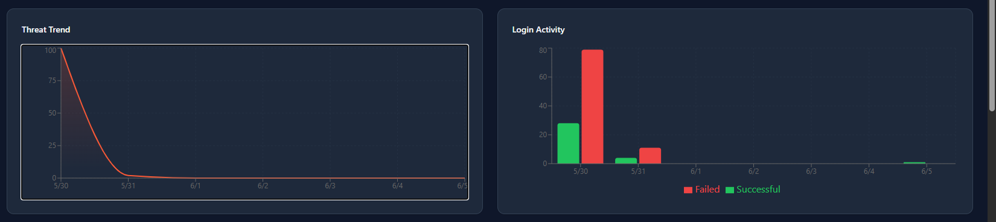
Figure 4.6: Bar Chart Showing Detected Attack Types
This chart compares the frequency of various attack categories detected by the system during testing.
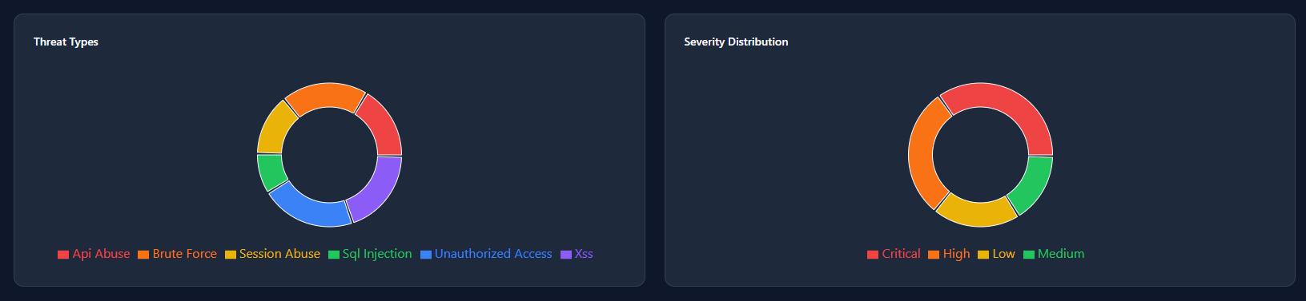
Figure 4.7: Pie Chart Showing Distribution of Detected Threats
Description:
This chart illustrates the proportion of different threat categories identified by the system.
4.4 System Evaluation and Testing
System testing was conducted to verify that the proposed intrusion detection system performs according to the specified requirements.
Validation
Validation focuses on determining whether the correct system was developed. The validation process involved comparing system functionalities with stakeholder requirements to ensure that all specified features were successfully implemented. The testing confirmed that the system effectively monitors traffic, detects suspicious activities, and generates alerts as intended.
Verification
Verification determines whether the system was developed correctly according to design specifications. Multiple test cases were executed to evaluate system behavior under different conditions. The results demonstrated that the system accurately processes requests, applies detection rules, and generates correct outputs.
Table 4.4: Sample Test Cases
Test Case | Expected Result | Actual Result | Status
Valid Login | Access Granted | Access Granted | Pass
Invalid Login | Access Denied | Access Denied | Pass
SQL Injection Attempt | Alert Generated | Alert Generated | Pass
Evaluation
The evaluation process measured the overall effectiveness of the system. Performance metrics such as detection accuracy, response time, false positive rate, and system reliability were analyzed. The results indicate that the proposed system performs efficiently and compares favorably with existing intrusion detection solutions.
4.5 System Documentation and Maintenance
System documentation provides detailed information regarding system operation, maintenance, and future enhancement.
Program Documentation
Program documentation describes the source code structure, processing logic, system modules, and implementation details. It serves as a guide for developers responsible for maintaining or modifying the system.
System Documentation
System documentation contains technical specifications including architecture diagrams, database design, and system workflows. It provides a comprehensive overview of how the system operates.
Operational Documentation
Operational documentation provides instructions for system deployment, startup procedures, backup processes, and routine maintenance activities.
User Documentation
User documentation contains guidelines for administrators and end users on how to interact with the system. It explains login procedures, dashboard usage, alert management, and report generation.
4.6 Benefits of the System
The implementation of the proposed Web-Based Intrusion Detection System provides numerous benefits. The system enhances security by continuously monitoring network activities and identifying malicious behavior in real time. It reduces the risk of unauthorized access, improves incident response capabilities, and assists administrators in maintaining the integrity and confidentiality of web resources. Furthermore, the system provides automated alert generation, comprehensive activity logging, and detailed reporting features that improve security management. Its web-based architecture enables remote monitoring, while its modular design facilitates future expansion and integration with other security solutions. The system also contributes to proactive threat detection, minimizing the likelihood of successful cyberattacks and reducing potential financial and operational losses.

CHAPTER FIVE
SUMMARY, CONCLUSION, AND RECOMMENDATIONS
5.1 Summary
This study focused on the design and implementation of a Web-Based Intrusion Detection System aimed at improving the security of web applications and network environments against cyber threats. The increasing reliance on web-based technologies has exposed organizations and individuals to various forms of cyberattacks, including unauthorized access, SQL injection attacks, cross-site scripting (XSS), brute force attacks, and other malicious activities. These security challenges have created a growing need for intelligent systems capable of monitoring network activities and detecting suspicious behavior in real time.
The study began by examining existing literature on cybersecurity, intrusion detection systems, network security principles, and web application security. Various intrusion detection approaches, including signature-based detection, anomaly-based detection, and hybrid detection techniques, were reviewed to establish a theoretical foundation for the research. The review also highlighted the limitations of conventional security mechanisms and the importance of real-time threat detection in modern computing environments.
A detailed analysis of the existing system was conducted to identify weaknesses and security vulnerabilities that could be exploited by attackers. Based on the findings, a Web-Based Intrusion Detection System was proposed and designed using appropriate system development methodologies. The proposed system architecture consisted of multiple components, including a user interface module, detection engine, database management module, and alert notification module. Several system modeling techniques such as Data Flow Diagrams (DFD), Entity Relationship Diagrams (ERD), Use Case Diagrams, Activity Diagrams, and Sequence Diagrams were utilized to represent the structure and behavior of the system.
The implementation phase involved the development of the system using modern web technologies and database management tools. The system was tested using various intrusion scenarios to evaluate its ability to detect malicious activities and generate appropriate alerts. The testing results demonstrated that the system was capable of effectively monitoring user activities, identifying suspicious requests, logging security events, and notifying administrators of potential threats. The findings confirmed that the proposed solution provides an effective mechanism for enhancing web application security and reducing the risk of successful cyberattacks.
5.2 Conclusion
The rapid growth of internet-based services and web applications has significantly increased the importance of cybersecurity in modern organizations. Traditional security measures alone are no longer sufficient to protect systems against sophisticated cyber threats. As attackers continue to develop more advanced techniques, organizations require intelligent monitoring solutions capable of identifying and responding to threats in real time.
This study successfully designed and implemented a Web-Based Intrusion Detection System that provides continuous monitoring and analysis of web traffic to detect suspicious activities. The system was developed to address the shortcomings of conventional security mechanisms by introducing automated threat detection, activity logging, and alert generation capabilities. Through the implementation and testing process, the system demonstrated its ability to identify potential security threats such as unauthorized access attempts, injection attacks, and abnormal user behavior.
The results obtained from the study indicate that the proposed system enhances the security posture of web applications by providing timely detection and notification of intrusion attempts. In addition to improving threat visibility, the system assists administrators in responding quickly to security incidents, thereby reducing the likelihood of data breaches and system compromise. The successful implementation of the system confirms that intrusion detection technology remains an essential component of modern cybersecurity strategies.
In conclusion, the objectives of this study were successfully achieved. The developed Web-Based Intrusion Detection System provides a practical and effective solution for monitoring, detecting, and reporting malicious activities within web environments. The system contributes to improved cybersecurity management and demonstrates the importance of proactive threat detection in protecting digital assets and sensitive information.
5.3 Recommendations
Based on the findings and outcomes of this research, several recommendations are proposed to further improve the effectiveness and applicability of the developed system.
Firstly, future versions of the system should incorporate machine learning and artificial intelligence techniques to improve detection accuracy and reduce false positive rates. Intelligent algorithms can enable the system to learn from historical attack patterns and adapt to emerging threats more effectively than traditional rule-based approaches.
Secondly, the system should be extended to support distributed and cloud-based environments. As many organizations are migrating their applications and services to cloud platforms, integrating cloud monitoring capabilities would enhance the system's ability to provide comprehensive security coverage across multiple environments.
Thirdly, future research should focus on integrating intrusion prevention functionalities into the system. While the current implementation primarily focuses on detecting and reporting malicious activities, an intrusion prevention mechanism would enable the system to automatically block suspicious requests and mitigate threats before they cause damage.
Furthermore, additional threat intelligence features should be incorporated to improve the system's ability to identify new and evolving attack techniques. Integration with external threat intelligence feeds and cybersecurity databases would allow the system to remain updated with the latest threat information and attack signatures.
Finally, organizations deploying the system should establish regular security audits, software updates, and user awareness training programs. While technology plays a significant role in cybersecurity, human factors remain a critical component of overall security effectiveness. Continuous training and awareness initiatives can help reduce vulnerabilities arising from human error and improve organizational resilience against cyber threats.

REFERENCES
Anderson, J. P. (1980). Computer security threat monitoring and surveillance. James P. Anderson Company.
Bace, R. G., & Mell, P. (2001). Intrusion detection systems (NIST Special Publication 800-31). National Institute of Standards and Technology.
Buczak, A. L., & Guven, E. (2016). A survey of data mining and machine learning methods for cyber security intrusion detection. IEEE Communications Surveys & Tutorials, 18(2), 1153–1176. https://doi.org/10.1109/COMST.2015.2494502
Denning, D. E. (1987). An intrusion-detection model. IEEE Transactions on Software Engineering, SE-13(2), 222–232. https://doi.org/10.1109/TSE.1987.232894
Elmasry, W., Akbulut, A., & Zaim, A. H. (2020). Evolving deep learning architectures for network intrusion detection using a double PSO metaheuristic. Computer Networks, 168, 107042. https://doi.org/10.1016/j.comnet.2019.107042
Goodfellow, I., Bengio, Y., & Courville, A. (2016). Deep learning. MIT Press.
Kim, D., & Solomon, M. G. (2018). Fundamentals of information systems security (3rd ed.). Jones & Bartlett Learning.
NIST. (2024). Cybersecurity framework (CSF) 2.0. National Institute of Standards and Technology. https://www.nist.gov/cyberframework
Scarfone, K., & Mell, P. (2007). Guide to intrusion detection and prevention systems (IDPS) (NIST Special Publication 800-94). National Institute of Standards and Technology.
Stallings, W., & Brown, L. (2018). Computer security: Principles and practice (4th ed.). Pearson.
Tanenbaum, A. S., & Wetherall, D. J. (2014). Computer networks (5th ed.). Pearson Education.
Verizon. (2024). 2024 data breach investigations report. Verizon Enterprise. https://www.verizon.com/business/resources/reports/dbir/
Appendix A

Appendix B
<?php
use App\Http\Controllers\AdminController;
use App\Http\Controllers\AlertManagementController;
use App\Http\Controllers\AnalystController;
use App\Http\Controllers\AuthController;
use App\Http\Controllers\IntrusionController;
use App\Http\Controllers\IpManagementController;
use App\Http\Controllers\ReportController;
use App\Http\Controllers\SettingController;
use App\Http\Controllers\UserController;
use App\Http\Controllers\UserManagementController;
use Illuminate\Support\Facades\Route;
use Inertia\Inertia;
Route::get('/', function () {
if (auth()->check()) {
$role = auth()->user()->role?->slug;
return match ($role) {
'admin' => redirect()->route('admin.dashboard'),
'analyst' => redirect()->route('analyst.dashboard'),
default => redirect()->route('user.dashboard'),
};
}
return Inertia::render('Welcome', [
'projectName' => 'Development of a Web-Based Intrusion Detection and Alert System',
'studentName' => 'Cathrine Emmanuel',
'matricNumber' => 'SDP/2024/0123',
'supervisorName' => 'Mrs. Mohammed M. O.',
]);
});
Route::middleware('guest')->group(function () {
Route::get('/login', [AuthController::class, 'showLogin'])->name('login');
Route::post('/login', [AuthController::class, 'login']);
Route::get('/register', [AuthController::class, 'showRegister'])->name('register');
Route::post('/register', [AuthController::class, 'register']);
});
Route::post('/logout', [AuthController::class, 'logout'])->name('logout');
Route::middleware('auth')->group(function () {
Route::prefix('admin')->name('admin.')->middleware('can:view-admin-dashboard')->group(function () {
Route::get('/dashboard', [AdminController::class, 'dashboard'])->name('dashboard');
Route::get('/users', [AdminController::class, 'users'])->name('users');
Route::get('/alerts', [AdminController::class, 'alerts'])->name('alerts');
Route::get('/threats', [AdminController::class, 'threats'])->name('threats');
Route::get('/blocked-ips', [AdminController::class, 'blockedIps'])->name('blocked-ips');
Route::get('/security-logs', [AdminController::class, 'securityLogs'])->name('security-logs');
Route::get('/activity-logs', [AdminController::class, 'activityLogs'])->name('activity-logs');
Route::get('/audit-logs', [AdminController::class, 'auditLogs'])->name('audit-logs');
Route::get('/settings', [AdminController::class, 'settings'])->name('settings');
Route::get('/threat-rules', [AdminController::class, 'threatRules'])->name('threat-rules');
Route::get('/reports', [ReportController::class, 'index'])->name('reports');
Route::get('/reports/daily', [ReportController::class, 'exportDaily'])->name('reports.daily');
Route::get('/reports/weekly', [ReportController::class, 'exportWeekly'])->name('reports.weekly');
Route::get('/reports/monthly', [ReportController::class, 'exportMonthly'])->name('reports.monthly');
Route::resource('user-management', UserManagementController::class)
->parameters(['user-management' => 'user'])
->names([
'index' => 'user-management.index',
Appendix C
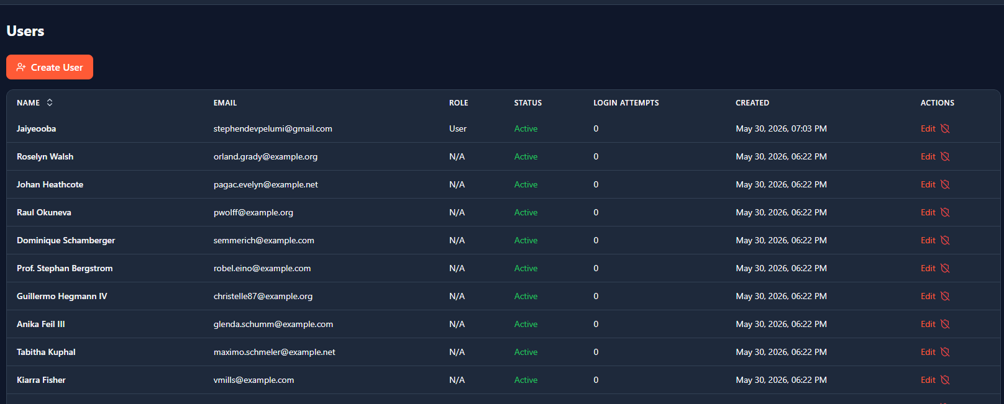
Figure c1 registered users

Figure c2: User Login Interface


Figure c3: Report
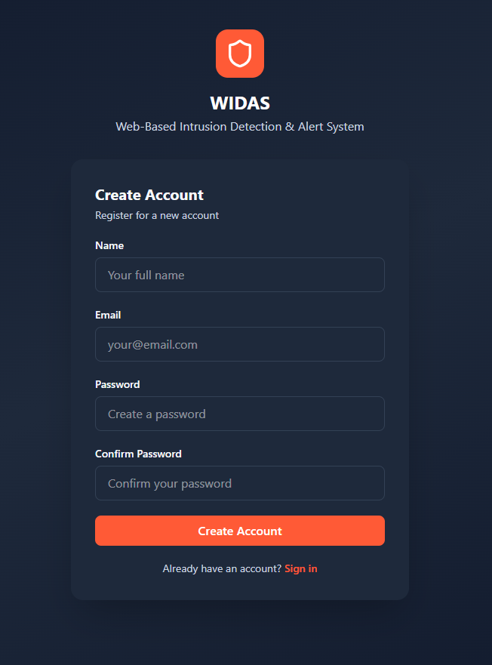
Figure c4: User registration Interface


Figure c5: Administrator Dashboard
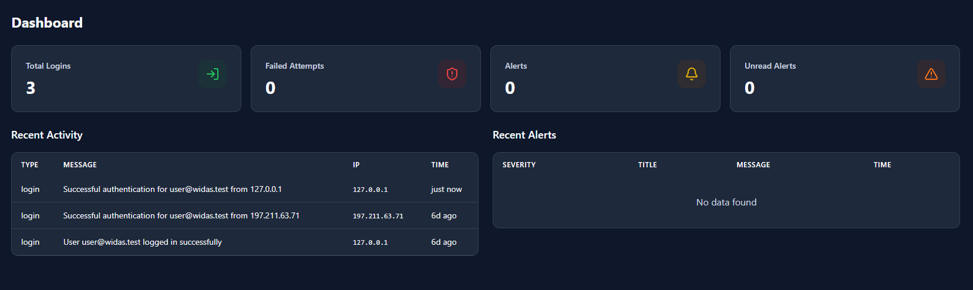
Figure c6: User Dashboard
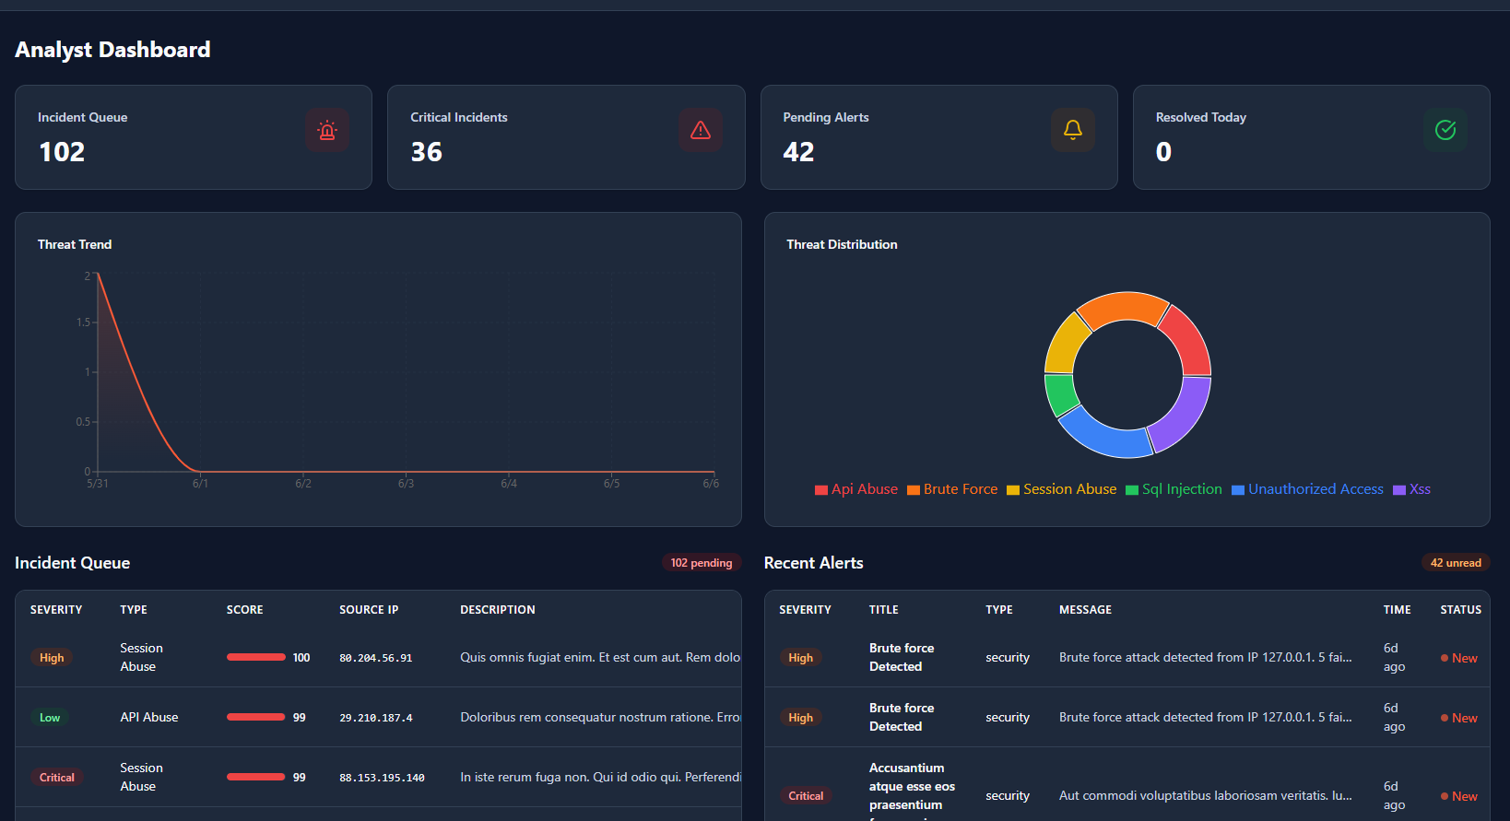
Figure c7: Analyst Dashboard

